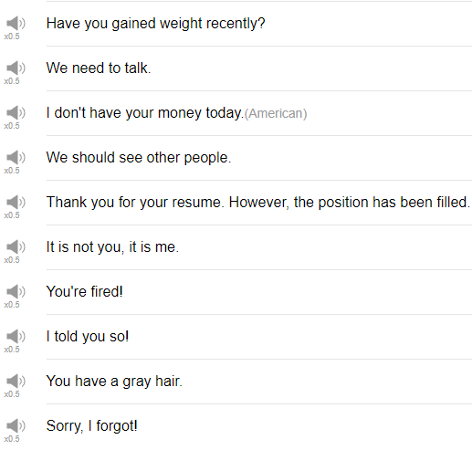

|  |
| --- |
| Hi, everybody! My name is Alisha and today we're going to be talking about 10 Phrases that You Never Want to Hear. so let's get into it! |
| 1. Have you gained weight recently? |
| The first phrase is "have you gained weight recently?" If someone is asking you this question, it means you look bigger than you did before. So for most people, this is not a good thing. Have you gained weight recently? Yeah, I have i've been eating too much junk food or "I don't think so", or "no". |
| 2. I don't have your money today. |
| So this phrase means maybe you were expecting money from someone and they don't have it for you today. So if your boss says this, for example, you're probably going to be really upset. I'm sorry but I don't have your money today. Really? I really needed it today. |
| 3. I told you so! |
| Kids might use this phrase, I told you so, this is kind of an overconfident phrase, I told you so. If you say "I told you" it's a little bit lighter, but "I told you so", like, nobody wants to hear that. Oh, I was wrong, or maybe this other person thinks, they were correct like they're making it into, like, I somehow know more than you do, so in a situation, let's see... "I shouldn't have gone out drinking last night, I should have gone home when you went home."I told you so, drunk person! |
| 4. It's not you, it's me. |
| This is a very common phrase for breakups, to show like you don't want to hurt the other person's feelings, it's just some problem I have, but either way nobody, nobody, wants to hear this phrase, it's not, you it's me. "Look, I'm really sorry but I think that it's better if we end our relationship here, it's not you, it's me. it's not you, it's me, really, I'm so sorry." "What? Oh! No! Please don't break up with me! No! I'll make you pie!" |
| 5. Sorry! I forgot! |
| I'm guilty of using this phrase quite a lot, unfortunately. I am a terrible forgetful human. If you're hearing this phrase, that means the other person was supposed to do something, or was supposed to do something, and they did not do it, they forgot about it, they forgot about it completely. Did you remember to let the dog out this morning? Oh! Sorry, I forgot! "What? It's going to destroy the house! I can't believe you forgot!" I know, I was in such a huge rush, i'm so sorry! |
| 6. Thank you for your resume, however the position has been filled. |
| The next one is Thank you for your resume, however the position has been filled. This might be the reply that you get, thank you for your resume, so we've seen your resume, we've accepted it, we've looked at it, but the job is already taken, someone else is already doing the job that you applied for. If it is on the phone, "thank you very much for your resume, however the position has already been filled." “Oh, really? Ok, well, thank you for the information.“ |
| 7. We need to talk. |
| You need to talk to me, stomach. Someone will often say this with a very serious tone of voice like "we need to talk". Of course you can use this with your friends, you know, maybe some serious secret happen, and you really want to talk to your friend about that, like we need to talk. But it's commonly used in romantic relationships when there's a problem, and you need to discuss this problem. “We really need to talk.” “Okay, what do you want to talk about?” "I know that you went out with someone else last weekend. ""What? Yeah, I went out last weekend but it was nothing." |
| 8. We should see other people. |
| The next phrase is "we should see other people". This is another common breakup phrase, when somebody is decided they don't want to be in a relationship anymore, and they will say we should see other people. See in this case means date other people, we should, you know, be in a relationship with other people. "I'm really sorry to tell you this, but I think we should see other people." "But, why? I've really enjoyed our relationship so far." Yeah, I don't think it's working out for me. |
| 9. You have a grey hair. |
| I find grey hair since I was 22. For a lot of people, finding grey hair means they're getting older. Oh! you have a grey hair! Really? where? "That's, ah! Take it out! Take it out! Oh really?! Another one! Dang!" Oh, really? Cool! I'm becoming a wizard! |
| 10. You're fired. |
| You're fired means you've lost your job, meaning you no longer have a job, you stop working here as of now, or in two weeks, or whatever. You don't want to hear this phrase, it means you've made a big mistake probably, at work. “I’m really sorry to have to tell you this but you're fired.” "What? But I need this job! I have to support my family! I need this money!" |
| That's the end of phrases that you really don't want to hear hopefully you don't have to use these phrases, hopefully you don't have to hear these phrases, but if you do maybe those are some ways that you can respond to them, or maybe the expected response to some of those phrases. So thank you very much for joining us for this lesson! Please please please do subscribe if you have not already. Next week we'll be back with some more fun stuff, so see you again soon! Bye! Oh no! |